EXPT NO: 1 | BUILDING AND TRAINING A SIMPLE ARTIFICIAL NEURAL NETWORK (ANN) FOR REGRESSION AND CLASSIFICATION
DATE:

PRE-LAB QUESTIONS (PROVIDE BRIEF ANSWERS TO THE FOLLOWING QUESTIONS)

1. What is an Artificial Neural Network (ANN)?
Answer:
An Artificial Neural Network (ANN) is a machine learning model inspired by the structure and functioning of the human brain. It consists of interconnected neurons organized into layers that learn patterns from data and are used for tasks such as regression and classification.

2. What are the functions of the input, hidden, and output layers in an ANN?
Answer:
- Input Layer: Receives the input features and passes them to the network.
- Hidden Layer: Processes the input using weights, biases, and activation functions to learn complex patterns.
- Output Layer: Produces the final prediction or classification result.

3. Why is feature scaling important before training an ANN?
Answer:
Feature scaling ensures that all input features are on a similar scale, which helps the neural network train faster and more efficiently. It also improves convergence and prevents features with larger values from dominating the learning process.

4. Differentiate between regression and classification problems with examples.
Answer:
Regression | Classification
Predicts continuous numerical values. | Predicts discrete class labels.
Example: Predicting house prices. | Example: Detecting whether a tumor is malignant or benign.

5. What is the role of the activation function in a neural network?
Answer:
The activation function introduces non-linearity into the neural network, enabling it to learn complex relationships in the data. Without activation functions, the network would only perform linear transformations and would not be able to solve complex problems effectively.

AIM
To understand the implementation of Artificial Neural Networks (ANN) using TensorFlow and evaluate their performance on regression and classification problems.

SOFTWARE REQUIREMENTS
- Python 3.x
- Google Colab / Jupyter Notebook
- TensorFlow 2.x
- NumPy
- Pandas
- Matplotlib
- Scikit-learn

LEARNING OBJECTIVES
After completing this experiment, students will be able to:
- Understand the architecture of an Artificial Neural Network.
- Build an ANN for regression problems.
- Build an ANN for classification problems.
- Train and evaluate neural network models.
- Compare different evaluation metrics used for regression and classification.

THEORY
An Artificial Neural Network (ANN) is a machine learning model inspired by the human brain. It consists of interconnected neurons organized into layers.
A simple ANN contains:
- Input Layer
- Hidden Layer(s)
- Output Layer
During training, the ANN learns by updating weights using Backpropagation and an optimization algorithm such as Adam Optimizer.

PART A – ANN FOR REGRESSION
DATASET: California Housing Dataset
SOURCE: Scikit-learn
DESCRIPTION
- Samples: 20,640
- Features: 8
- Target: Median House Value

FEATURES
Feature | Description
MedInc | Median Income
HouseAge | House Age
AveRooms | Average Rooms
AveBedrms | Average Bedrooms
Population | Population
AveOccup | Average Occupancy
Latitude | Latitude
Longitude | Longitude

ALGORITHM
- Import libraries.
- Load California Housing dataset.
- Split into training and testing sets.
- Standardize the features.
- Build ANN model.
- Compile the model.
- Train the model.
- Predict house prices.
- Evaluate using:
  - MSE
  - MAE
  - RMSE

(CODE: CONATAINS STUDENT ROLL NOS
SCREENSHOT OF CODE
SCREENSHOT OF OUTPUT)

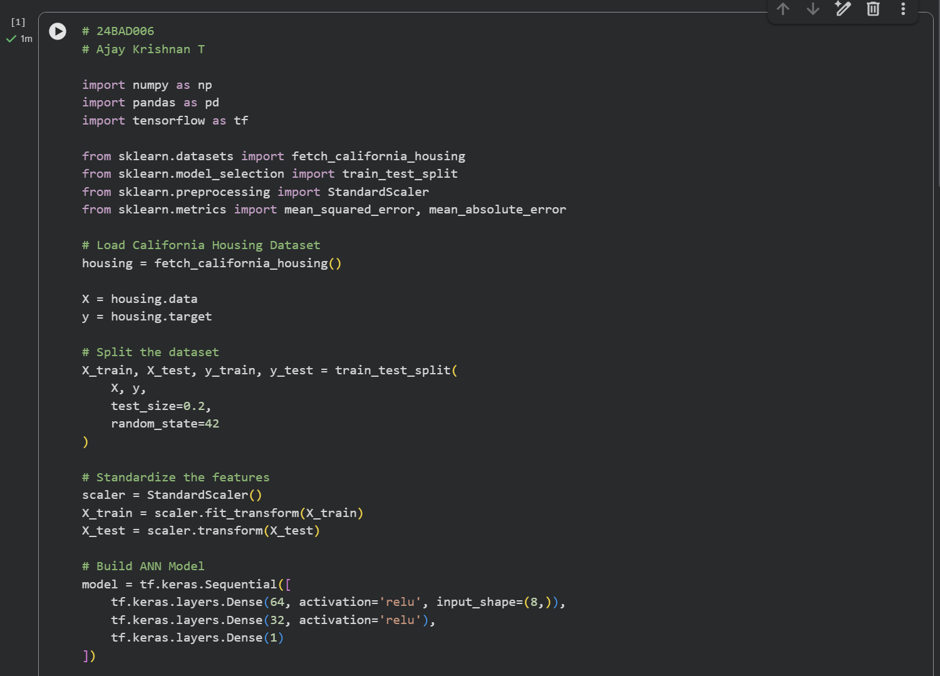
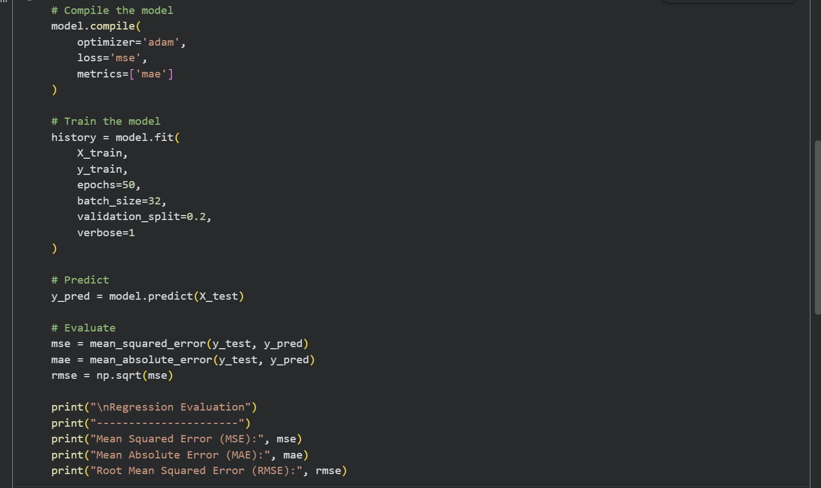
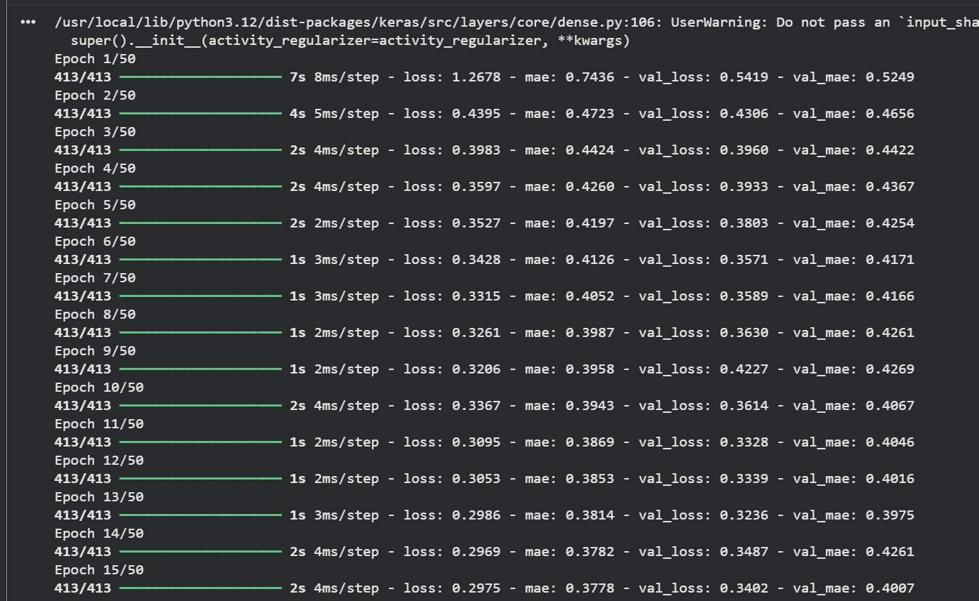
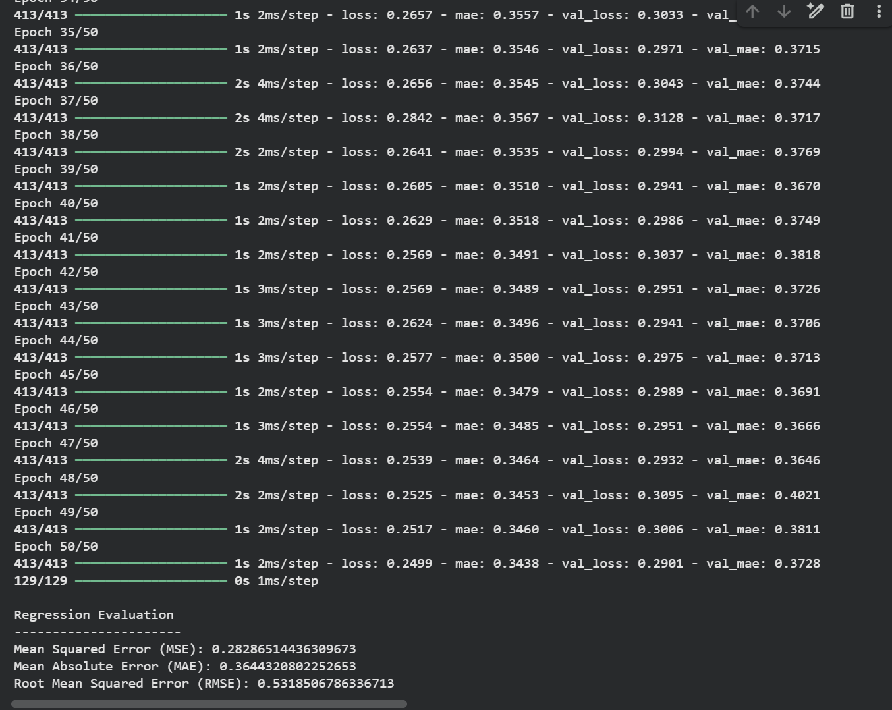

PART B – ANN FOR CLASSIFICATION
DATASET: Breast Cancer Wisconsin Dataset
SOURCE: Scikit-learn
DESCRIPTION
- Samples: 569
- Features: 30
- Classes:
  - Malignant
  - Benign

ALGORITHM
- Import libraries.
- Load Breast Cancer dataset.
- Split dataset.
- Standardize features.
- Design ANN.
- Compile model.
- Train model.
- Predict labels.
- Evaluate:
  - Accuracy
  - Precision
  - Recall
  - F1-score
  - Confusion Matrix

(CODE: CONATAINS STUDENT ROLL NOS
SCREENSHOT OF CODE
SCREENSHOT OF OUTPUT)

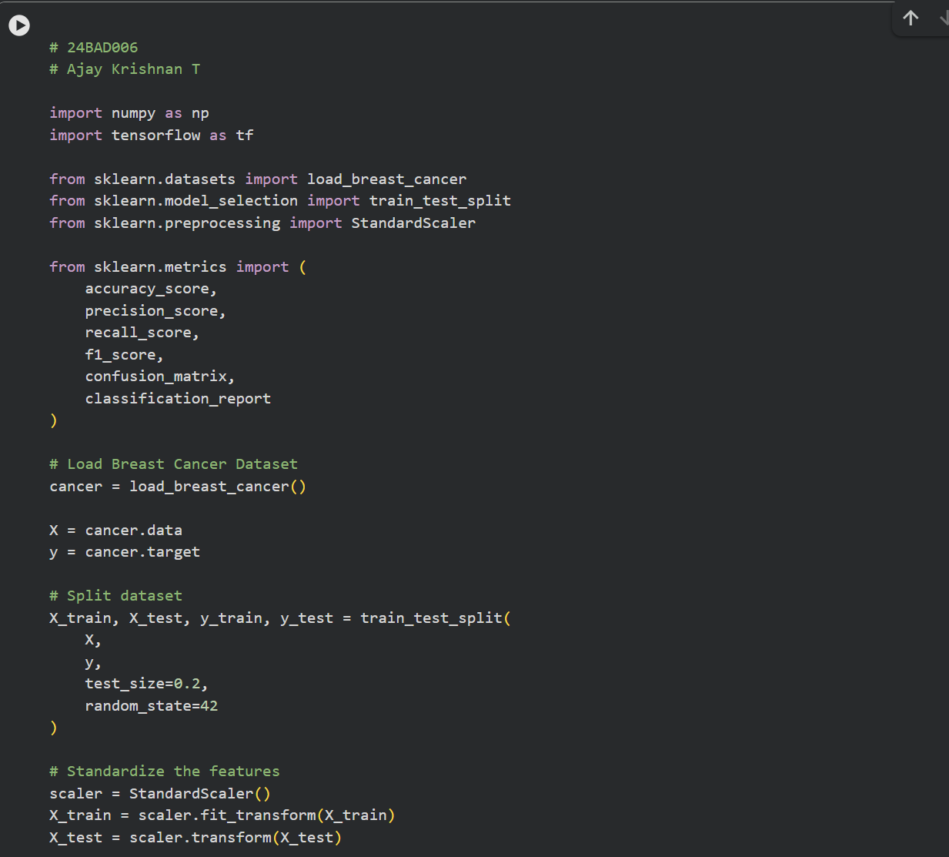
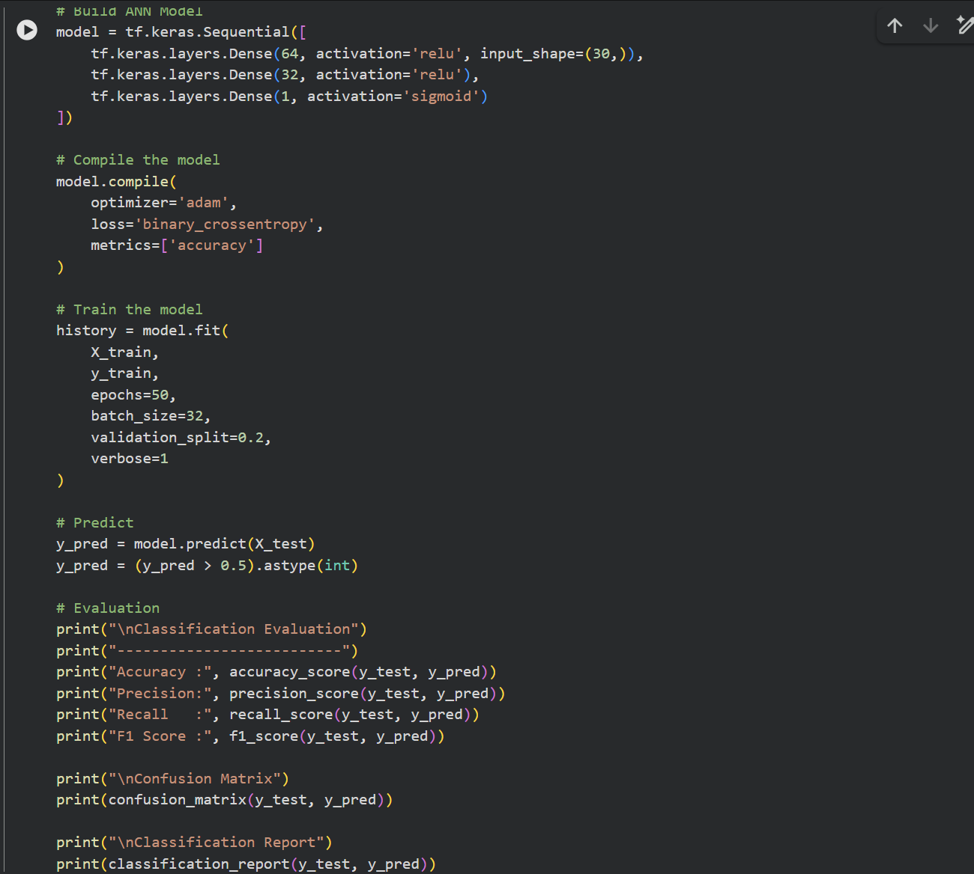
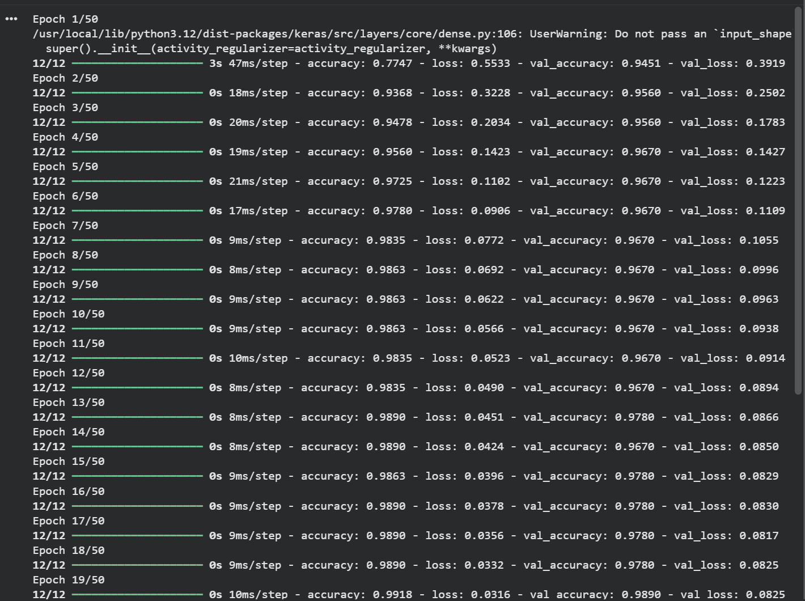
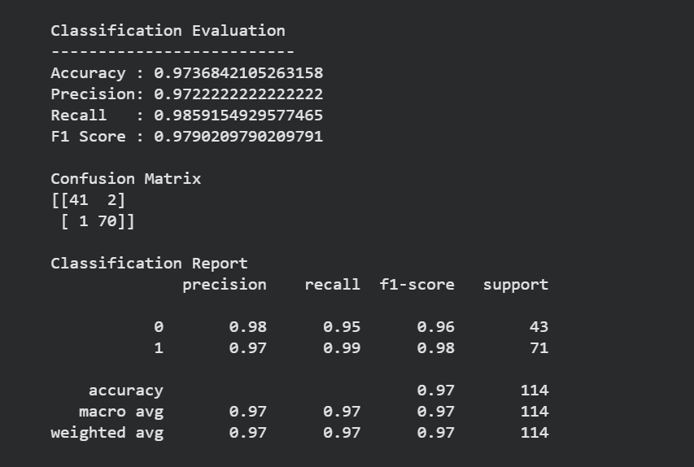

POST-LAB QUESTIONS (PROVIDE BRIEF ANSWERS TO THE FOLLOWING QUESTIONS)

1. Why is the Adam optimizer commonly used in ANN training?
Answer:
The Adam optimizer is commonly used because it combines the advantages of Momentum and RMSProp. It automatically adjusts the learning rate for each parameter, resulting in faster convergence, efficient training, and better performance on large and complex datasets.

2. Compare Mean Squared Error (MSE) and Mean Absolute Error (MAE). Which metric is more sensitive to outliers?
Answer:
Mean Squared Error (MSE) calculates the average of the squared differences between predicted and actual values, while Mean Absolute Error (MAE) calculates the average of the absolute differences. Since MSE squares the errors, it gives more weight to large errors and is therefore more sensitive to outliers than MAE.

3. Why is the sigmoid activation function used in binary classification?
Answer:
The sigmoid activation function is used in binary classification because it converts the output into a value between 0 and 1, representing the probability of belonging to a particular class. This makes it suitable for predicting two classes, such as malignant or benign.

4. How does increasing the number of hidden layers affect the performance of an ANN?
Answer:
Increasing the number of hidden layers enables the ANN to learn more complex patterns and improve prediction accuracy. However, adding too many hidden layers may increase training time, computational cost, and the risk of overfitting if not properly managed.

5. Compare the evaluation metrics used for regression and classification tasks. Why are different metrics required for these problems?
Answer:
Regression tasks use metrics such as Mean Squared Error (MSE), Mean Absolute Error (MAE), and Root Mean Squared Error (RMSE) to measure the difference between predicted and actual continuous values. Classification tasks use metrics such as Accuracy, Precision, Recall, F1-score, and the Confusion Matrix to evaluate how well the model predicts class labels. Different metrics are required because regression predicts continuous numerical values, whereas classification predicts discrete categories.

ASSESSMENT
Description | Max Marks | Marks Awarded
Pre Lab Exercise | 5
In Lab Exercise | 10
Post Lab Exercise | 5
Viva | 10
Total | 30
Faculty Signature

